EUROPE AFTER NAPOLEON

UNTIL UNIFICATION WEBQUEST

Part I: Europe after the Congress of Vienna
Directions: Click on the links to the right about the years after the Congress of Vienna to answer the questions below: Links to "Revolutionary Europe Website" and the "Revolutions of 1830 & 1848"
1. From your notes, reading and memory... what were the main goals of Prince Metternich & the Congress of Vienna?
2. Identify (IN YOUR OWN WORDS) what the two major mistakes of the Congress of Vienna were?
3. How would Napoleon's policies have a profound effect on the people of Europe long after his death?
4. How did nationalism play a role in 19th century Europe?
5. What were the driving forces behind the revolutions of 1830 and 1848?
6. Why are these revolutions so important if they didn't technically "succeed"?

Part II: Europe after the Revolutions of 1848
Directions: Use links to the right about Europe after 1848: Link to "Europe after 1848" and map of Crimean War
1. What two burgeoning nations threatened the "balance of power" created by the Congress of Vienna? HOW would they do this?
2. Why did Russia and the Ottoman Empire fight one another in the Crimean War?
3. Why did France and Britain side with the Muslim nation instead of the Christian one? How does this mirror France's decision in the Thirty Years' War?

Part III: Basic Info Unification of Italy and Germany
Directions: Click here to visit the site you need to answer the following questions: Unification Website
- What 2 groups began to cooperate with their governments rather than try to overthrow them?
- What did many governments learn about allowing certain liberal reforms?
- During the second half of the 19th Century, what dominated Europe?
- What 2 new states were formed at this time?
- What even are we setting the stage to study next?
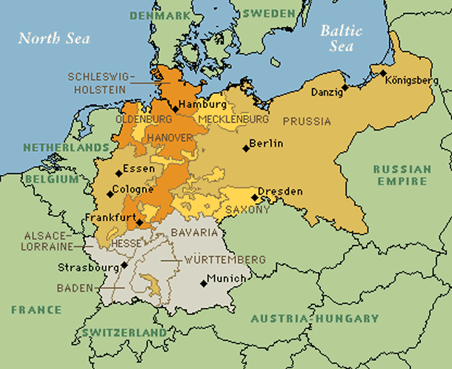

Part IV: Unification of Germany
Directions: Use the above map of Germanic states as a reference. You will find the links about German unification from the main website you clicked on above.
- Why would it be incorrect to say that revolution caused German unification?
- Why did Prussia and Austria fight Denmark in 1864?
- Why did Bismarck want to go to war with Austria?
- What did Bismarck want to happen by sending the Ems Telegramme to newspapers
- When was Germany created as a unified country and what event marked this?

